Dashboard Page
NextPMS Dashboard Wiki

This document is the NextPMS 2.0 Dashboard and Tracking. Its purpose is to serve as a comprehensive technical guide and reference manual for internal teams regarding the application's metric tracking, KPI formulas, and database calculation logics. It explicitly documents the data rules and backend API endpoints powering distinct features across the platform, including financial KPIs, resource allocation heatmaps, project tracking metrics, and cost burn calculations.

Revenue, Cost & Profit Margin
/api/method/next_pms.api.dashboard.get_leadership_kpis

Revenue is calculated as the sum of grand_total from submitted sales invoices within the period. All amounts are converted to USD for comparison. Current and previous period totals are computed in a single query and compared to show the trend.
Cost is calculated as the sum of costing_amount from Timesheet Detail entries (each employee's logged time × their cost rate) within the period. All amounts are converted to USD. Both draft and submitted timesheets are included.
Profit margin is calculated as (Revenue − Cost) / Revenue × 100, giving a percentage. It's computed for both the current and previous periods using the already-calculated USD revenue and cost figures, then compared to show the trend.

Allocation Heatmap

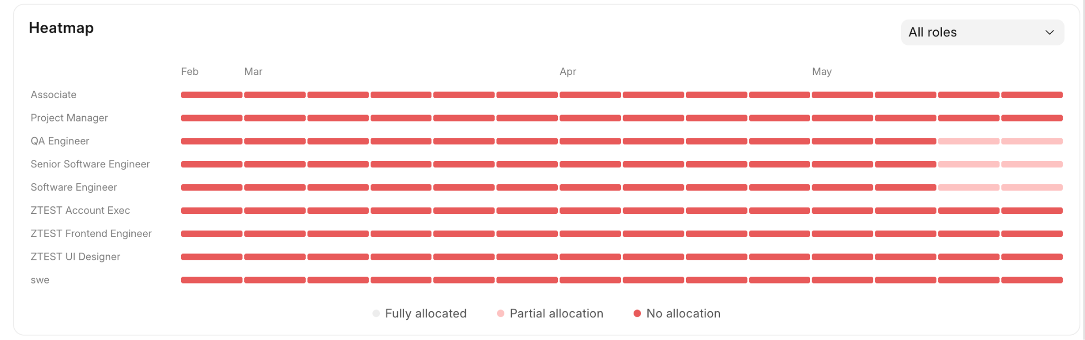
/api/method/next_pms.api.dashboard.get_allocation_heatmap

For each job role, and for each week in the selected date range, we calculate two numbers: total available hours (sum of all employees' working hours on working days) and total booked hours (sum of their confirmed resource allocations). Working days exclude holidays and, by default, weekends. Weekends are only counted if Allow Weekend Entries is enabled in Timesheet Settings. This powers the allocation heatmap so you can see which roles are under- or over-allocated week by week.

KPI Cards

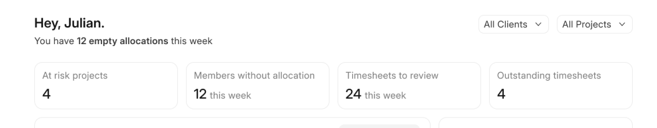
Active Projects
/api/method/next_pms.api.dashboard.get_active_projects_count
Returns the count of currently active projects. Optionally filtered by client or a specific project.

At Risk Projects
/api/method/next_pms.api.dashboard.get_at_risk_projects_count
Returns the count of active projects with a RAG status of Red or Amber. Optionally filtered by client or project.

Get Members Without Allocation
/api/method/next_pms.api.dashboard.get_members_without_allocation
Returns active employees who are under-allocated on at least one working day in the look-back window (default: 7 days). An employee is flagged when their confirmed allocation hours for a day are less than their expected daily working hours. Weekends are excluded unless Allow Weekend Entries is enabled in Timesheet Settings. Note: holidays are not excluded here. Returns a count and per-employee breakdown with the specific dates and missing hours.

Get Non Billable Hours
/api/method/next_pms.api.dashboard.get_non_billable_hours
Returns the total non-billable hours logged in Timesheet Detail entries within the given look-back window (default: 30 days). Only entries marked as non-billable (is_billable = 0) are counted. Optionally filtered by client or project.

Get Timesheets to Review
/api/method/next_pms.api.dashboard.get_timesheets_to_review
Returns timesheets that are pending approval from the current user's direct reports. Only timesheets submitted within the given look-back window (default: 7 days) and with an "Approval Pending" status are returned.

Get Outstanding Timesheets
/api/method/next_pms.api.dashboard.get_outstanding_timesheets
Returns the current user's direct reports who are missing timesheets on one or more past working days (default: 7 days, ending yesterday. Today is excluded). Full-day approved or open leave and public holidays exempt a day from the check; half-day leave still requires a timesheet. Weekends are included only if Allow Weekend Entries is enabled. Returns a count and per-employee breakdown with the specific missing dates.

Utilized Time & Forecast Breakdown
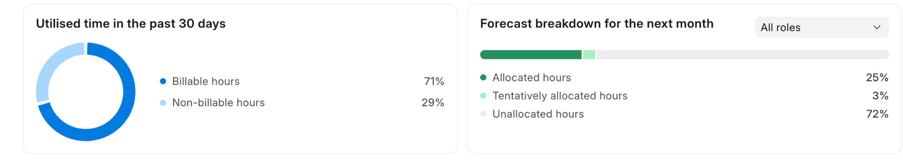
Utilised Time
/api/method/next_pms.api.dashboard.get_time_utilisation
Returns the total billable and non-billable hours logged across all timesheets in the given window. Optionally filtered by employee designation. All timesheets not rejected are included.

Forecast Breakdown
/api/method/next_pms.api.dashboard.get_forecast_breakdown
Returns a forward-looking breakdown of how team capacity is being used, starting from today, over the given number of days. For each job role, shows three numbers: confirmed allocated hours, tentative hours, and unallocated (free) hours. Weekends and employee holidays are excluded from the calculation. Employees without a designation are not included. This powers the forecast view so you can see which roles have capacity available and which are fully booked.

Calendar Timeline Items
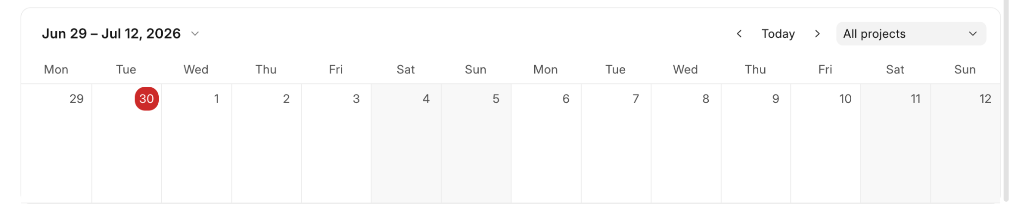
/api/method/next_pms.api.dashboard.get_calendar_timeline_items

This calendar view shows the tasks or milestones that are associated with the projects.

Assigned Projects Summary
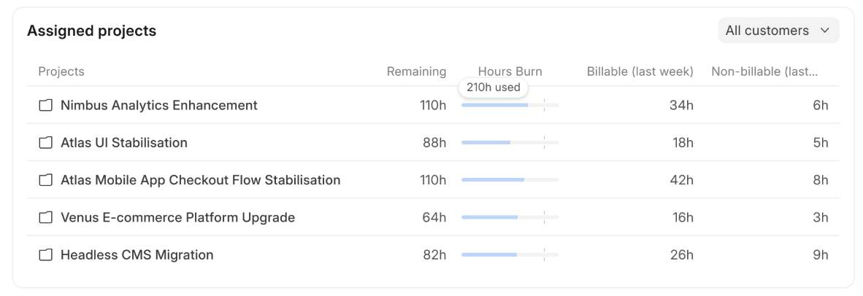
/api/method/next_pms.api.dashboard.get_my_projects_summary

Returns the data on every open project the user is project manager of. Billable & Non billable hours are calculated for last n days (last week as default) from the timesheets (submitted and draft)

Timesheets & Upcoming Time-offs
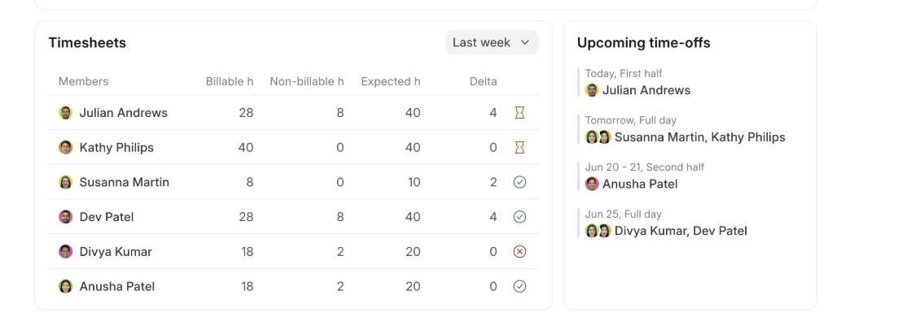
Timesheet Summary
/api/method/next_pms.api.dashboard.get_team_timesheets
Returns a timesheet summary for each active direct report of the current user, over a given look-back window (default: 7 days). For each team member, it shows billable hours, non-billable hours, expected hours, the gap between expected and logged hours (delta), and their weekly approval status. Expected hours are calculated from the employee's daily working hours multiplied by the number of working days in the window. Weekends are excluded unless Allow Weekend Entries is enabled in Timesheet Settings. Public holidays are excluded based on each employee's personal holiday list. Leaves are not excluded, meaning an employee on approved leave who has not logged hours will still show a gap in their delta.

Employees on Leave
/api/method/next_pms.api.dashboard.get_employees_on_leave
Returns a list of the current user's direct reports who are on approved leave today or in the future. Only approved leave applications are included.

Notifications
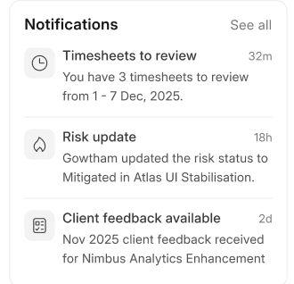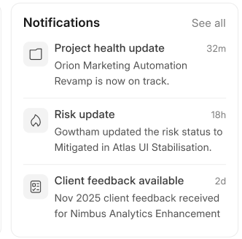
/desk/nextpms-notifications
Notifications are logged for
1. Timesheets to Review
2. Risk Status Update
3. Client Feedback
4. Project RAG Status Update

Project Tracking Page

NextPMS Project Tracking Wiki

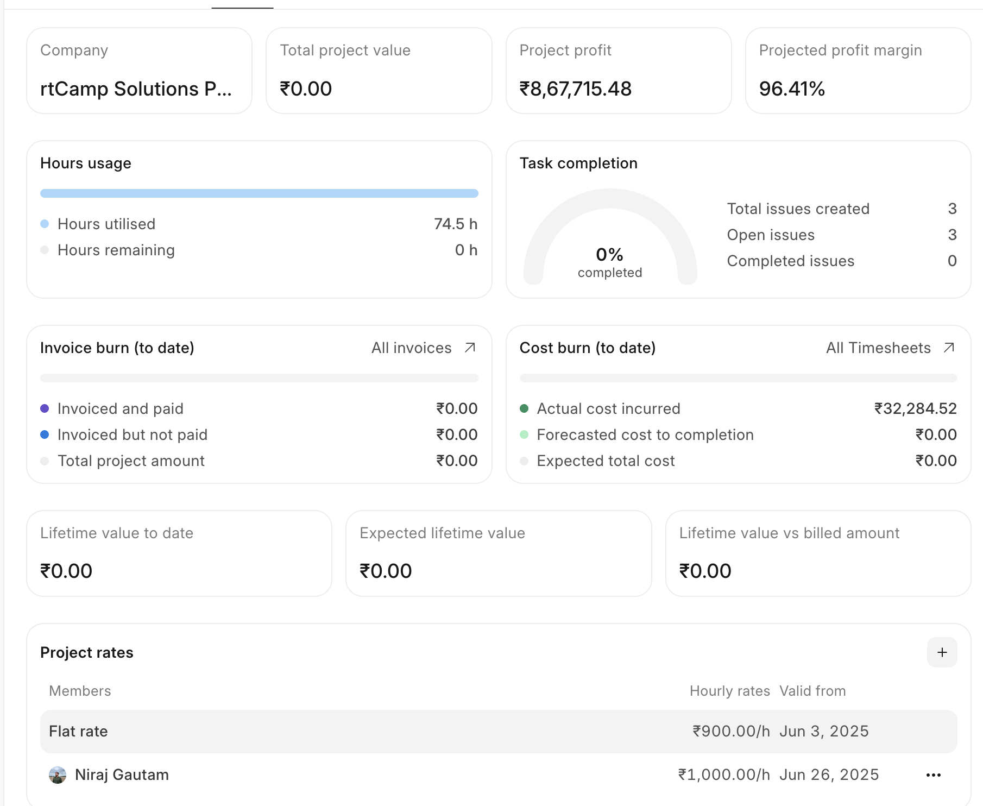

/api/method/next_pms.next_projects.api.project.get_project_tracking

Company - Company associated with the project
Total Project Value - Total Sales Amount (via Sales Order) from the project document (if billable project)
Project Profit - Total project value (i.e. Total Sales Amount (via Sales Order)) - ((Total Costing Amount (via Timesheet)) + Forecasted cost to completion)
Projected Profit Margin - Projected profit / Total project value * 100 (if billable project)

Hours Usage
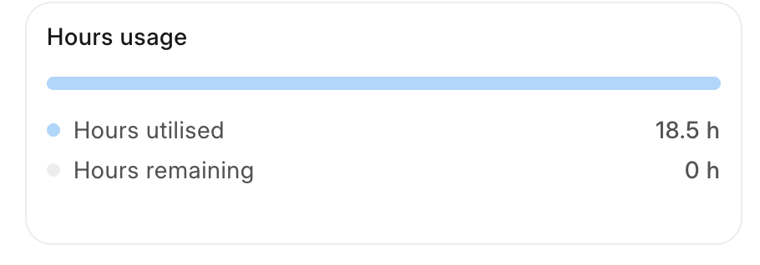
Billable hours utilised
Non-billable hours utilised
Total hours utilised = Actual Time in Hours (via Timesheet)
Total hours remaining

Hours Utilised - Actual Time in Hours (via Timesheet)
Hours Remaining - Total Hours Remaining (if billing_type in fixed cost or retainer) else Target Hours - Actual Time in Hours (via Timesheet)

Task Completion
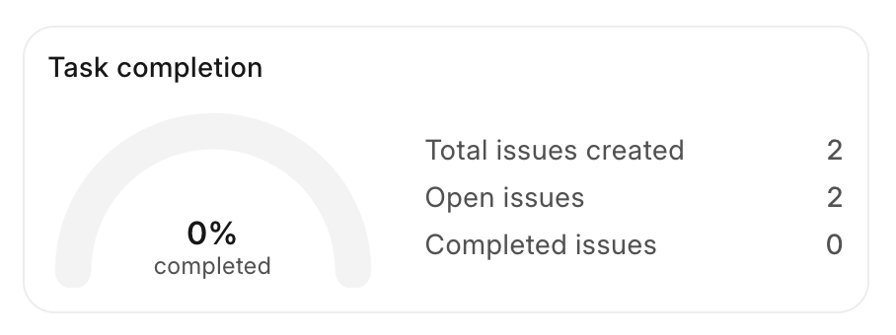
Total issues created - all tasks assigned to a project with the statuses open, working, pending review, overdue and completed
Open issues - open, working, pending review, overdue
Completed issues - completed only.
Template and cancelled tasks are excluded from all counts.

Invoice Burn (to date):
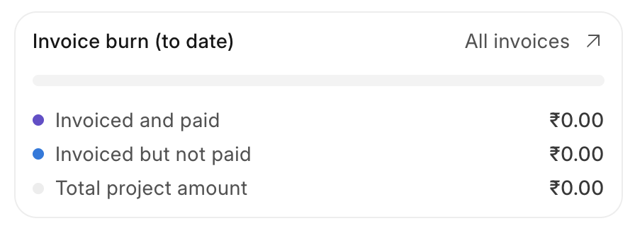
Currency is the company default currency.

Invoiced and paid - The total amount that has already been collected from the client. For each submitted invoice, we take the full invoice amount in company currency (base_grand_total) and subtract what is still outstanding (also converted to company currency). Summed across all submitted invoices for the project.

Invoiced but not paid - The total amount that has been billed to the client but not yet collected. For each submitted invoice, we take the outstanding balance and convert it to company currency using the invoice's exchange rate. Summed across all submitted invoices for the project.

Total Project Amount - Total Sales Amount (via Sales Order) from the project document (if billable project)

Cost Burn (to date)
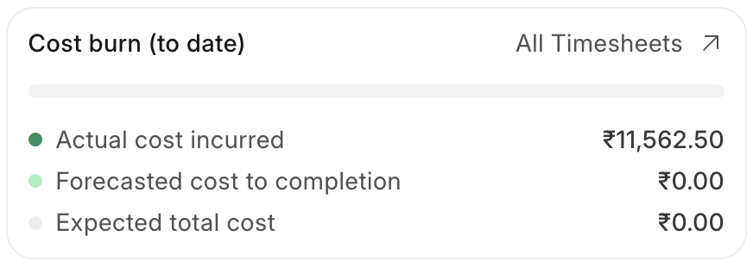
Actual cost incurred - Total Costing Amount (via Timesheet) field. Auto filled. It sums costing_amount (hours × employee cost rate) from all submitted Timesheet Detail entries linked to the project, across all time.

Forecasted cost to completion - The estimated remaining cost to complete the project. Calculated as the total planned cost across all resource allocations minus what has already been spent based on logged timesheets. If actual spend has exceeded the forecast, this value is shown as zero rather than negative.
Forecast Cost to Completion = Total Planned Cost - Actual Spend (based on logged timesheets).

Expected total cost - target cost field in the project. (It needs to be updated manually)

Lifetime Value Cards

Lifetime Value to Date - Manual field. Present if billable project.
Expected Lifetime Value - Manual field. Present if billable project.
Lifetime Value vs billed amount - Manual field. Present if billable project.

Project Rates
Visible if billing type is T&M
Flat rate (hourly) - Default hourly billing rate
Flat rate (valid from) - Actual start date (via timesheet) field

Rates from Project Billing team field in project document. Example:
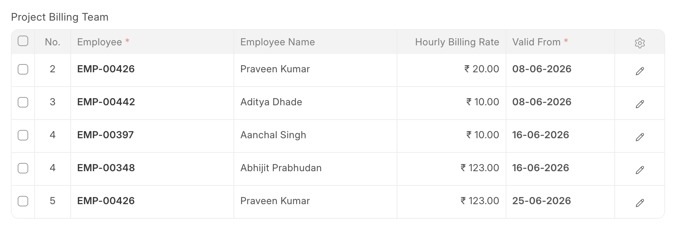

Contracts
Visible if project billing type is Fixed cost or Retainer
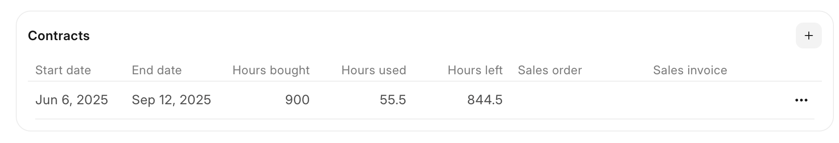
Data from project hours by contract field. Example: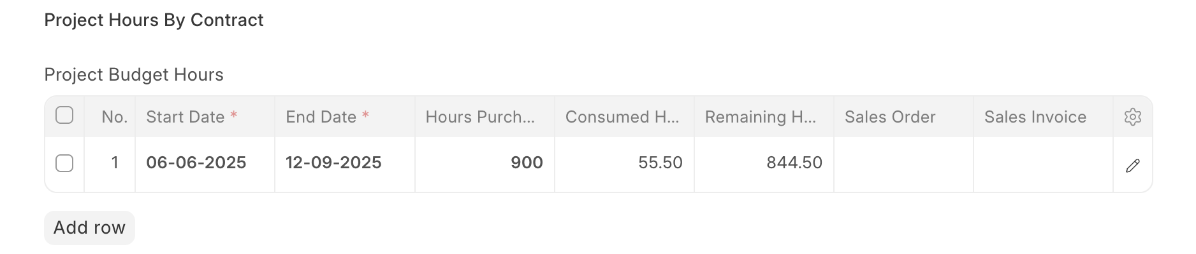

Project Sidebar

Project Sidebar and List View

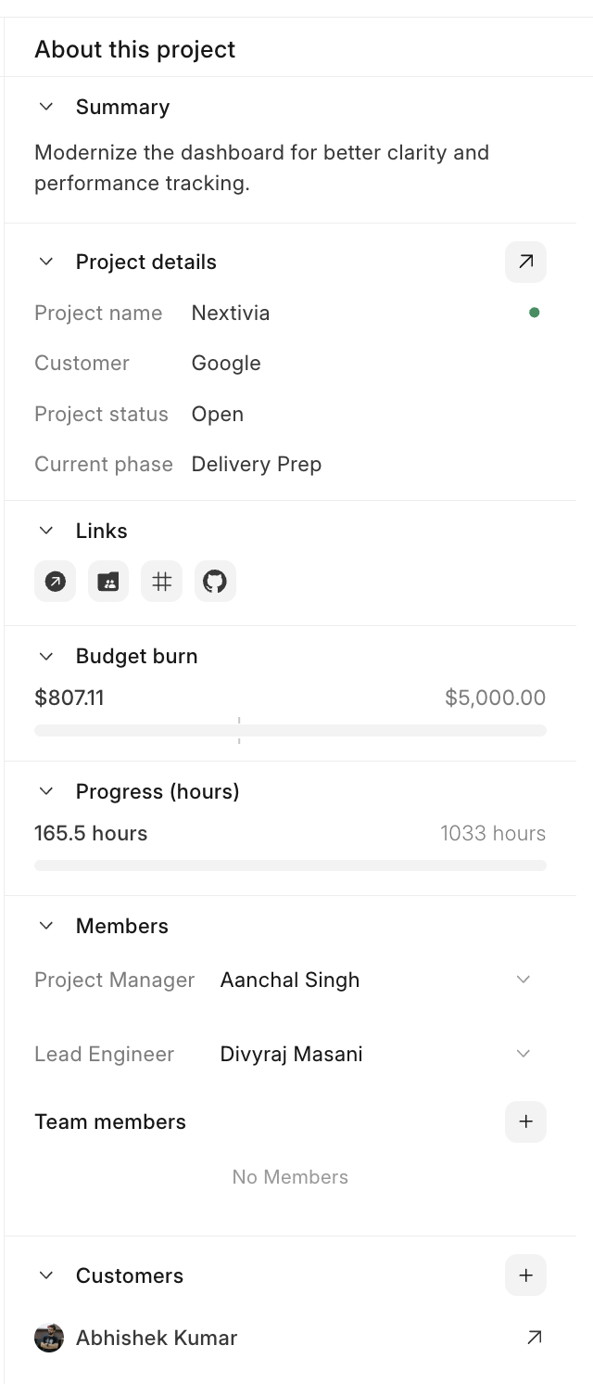

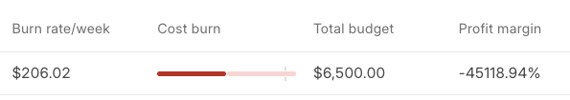

Burn rate/week
Average budget consumed per week based on charge-out rate × hours worked.
- Formula: `total_billable_amount ÷ weeks elapsed`, where weeks elapsed = `max(1, (today − expected_start_date) / 7)`.
- Condition: shown blank if the project has no billable amount yet or no expected start date.
Cost burn
Progress bar with three markers, all as % of Total budget:
- Filled bar (cost accrued): `total_costing_amount ÷ total_budget × 100`. Costing amount is auto-filled from submitted Timesheet Detail entries (hours × employee cost rate).
- Secondary bar (cost forecasted): sum of `total_cost` from the project's Resource Allocations whose end date is today or later, ÷ total_budget × 100. Past allocations are excluded — their cost is already realized in cost accrued via timesheets.
- Marker (target cost): `custom_target_cost ÷ total_budget × 100`.
- Condition: all three are 0 when total budget ≤ 0.

Total budget
- If billable: `total_sales_amount` (total sales amount from linked Sales Orders).
- If Non-Billable: `estimated_costing`.
Profit margin
- Formula: `(total_budget − (cost_accrued + cost_forecasted)) ÷ total_budget × 100`.
- Condition: 0 when total budget ≤ 0.

